Chinook Music Store Project

Objective Questions:
- Does any table have missing values or duplicates? If yes, how would you handle it ?
Answer

Query
-- NULLs in CUSTOMER
DESC customer;

SELECT 'customer.customer_id' AS column_name, COUNT(*) FROM customer WHERE customer_id IS NULL UNION ALL
SELECT 'customer.first_name', COUNT(*) FROM customer WHERE first_name IS NULL UNION ALL
SELECT 'customer.last_name', COUNT(*) FROM customer WHERE last_name IS NULL UNION ALL
SELECT 'customer.company', COUNT(*) FROM customer WHERE company IS NULL UNION ALL
SELECT 'customer.address', COUNT(*) FROM customer WHERE address IS NULL UNION ALL
SELECT 'customer.city', COUNT(*) FROM customer WHERE city IS NULL UNION ALL
SELECT 'customer.state', COUNT(*) FROM customer WHERE state IS NULL UNION ALL
SELECT 'customer.country', COUNT(*) FROM customer WHERE country IS NULL UNION ALL
SELECT 'customer.postal_code', COUNT(*) FROM customer WHERE postal_code IS NULL UNION ALL
SELECT 'customer.phone', COUNT(*) FROM customer WHERE phone IS NULL UNION ALL
SELECT 'customer.fax', COUNT(*) FROM customer WHERE fax IS NULL UNION ALL
SELECT 'customer.email', COUNT(*) FROM customer WHERE email IS NULL UNION ALL
SELECT 'customer.support_rep_id', COUNT(*) FROM customer WHERE support_rep_id IS NULL;

-- NULLs in EMPLOYEE
DESC employee;

SELECT 'employee.employee_id', COUNT(*) FROM employee WHERE employee_id IS NULL UNION ALL
SELECT 'employee.last_name', COUNT(*) FROM employee WHERE last_name IS NULL UNION ALL
SELECT 'employee.first_name', COUNT(*) FROM employee WHERE first_name IS NULL UNION ALL
SELECT 'employee.title', COUNT(*) FROM employee WHERE title IS NULL UNION ALL
SELECT 'employee.reports_to', COUNT(*) FROM employee WHERE reports_to IS NULL UNION ALL
SELECT 'employee.birth_date', COUNT(*) FROM employee WHERE birthdate IS NULL UNION ALL
SELECT 'employee.hire_date', COUNT(*) FROM employee WHERE hire_date IS NULL UNION ALL
SELECT 'employee.address', COUNT(*) FROM employee WHERE address IS NULL UNION ALL
SELECT 'employee.city', COUNT(*) FROM employee WHERE city IS NULL UNION ALL
SELECT 'employee.state', COUNT(*) FROM employee WHERE state IS NULL UNION ALL
SELECT 'employee.country', COUNT(*) FROM employee WHERE country IS NULL UNION ALL
SELECT 'employee.postal_code', COUNT(*) FROM employee WHERE postal_code IS NULL UNION ALL
SELECT 'employee.phone', COUNT(*) FROM employee WHERE phone IS NULL UNION ALL
SELECT 'employee.fax', COUNT(*) FROM employee WHERE fax IS NULL UNION ALL
SELECT 'employee.email', COUNT(*) FROM employee WHERE email IS NULL;

-- NULLs in ARTIST
DESC artist;

SELECT 'artist.artist_id', COUNT(*) FROM artist WHERE artist_id IS NULL UNION ALL
SELECT 'artist.name', COUNT(*) FROM artist WHERE name IS NULL;

-- NULLs in ALBUM
DESC album;

SELECT 'album.album_id', COUNT(*) FROM album WHERE album_id IS NULL UNION ALL
SELECT 'album.title', COUNT(*) FROM album WHERE title IS NULL UNION ALL
SELECT 'album.artist_id', COUNT(*) FROM album WHERE artist_id IS NULL;

-- NULLs in TRACK
DESC track;

SELECT 'track.track_id', COUNT(*) FROM track WHERE track_id IS NULL UNION ALL
SELECT 'track.name', COUNT(*) FROM track WHERE name IS NULL UNION ALL
SELECT 'track.album_id', COUNT(*) FROM track WHERE album_id IS NULL UNION ALL
SELECT 'track.media_type_id', COUNT(*) FROM track WHERE media_type_id IS NULL UNION ALL
SELECT 'track.genre_id', COUNT(*) FROM track WHERE genre_id IS NULL UNION ALL
SELECT 'track.composer', COUNT(*) FROM track WHERE composer IS NULL UNION ALL
SELECT 'track.milliseconds', COUNT(*) FROM track WHERE milliseconds IS NULL UNION ALL
SELECT 'track.bytes', COUNT(*) FROM track WHERE bytes IS NULL UNION ALL
SELECT 'track.unit_price', COUNT(*) FROM track WHERE unit_price IS NULL;

-- NULLs in INVOICE
DESC invoice;

SELECT 'invoice.invoice_id', COUNT(*) FROM invoice WHERE invoice_id IS NULL UNION ALL
SELECT 'invoice.customer_id', COUNT(*) FROM invoice WHERE customer_id IS NULL UNION ALL
SELECT 'invoice.invoice_date', COUNT(*) FROM invoice WHERE invoice_date IS NULL UNION ALL
SELECT 'invoice.billing_address', COUNT(*) FROM invoice WHERE billing_address IS NULL UNION ALL
SELECT 'invoice.billing_city', COUNT(*) FROM invoice WHERE billing_city IS NULL UNION ALL
SELECT 'invoice.billing_state', COUNT(*) FROM invoice WHERE billing_state IS NULL UNION ALL
SELECT 'invoice.billing_country', COUNT(*) FROM invoice WHERE billing_country IS NULL UNION ALL
SELECT 'invoice.billing_postal_code', COUNT(*) FROM invoice WHERE billing_postal_code IS NULL
UNION ALL
SELECT 'invoice.total', COUNT(*) FROM invoice WHERE total IS NULL;

-- NULLs in INVOICE_LINE
DESC invoice_line;

SELECT 'invoice_line.invoice_line_id', COUNT(*) FROM invoice_line WHERE invoice_line_id IS NULL UNION ALL
SELECT 'invoice_line.invoice_id', COUNT(*) FROM invoice_line WHERE invoice_id IS NULL UNION ALL
SELECT 'invoice_line.track_id', COUNT(*) FROM invoice_line WHERE track_id IS NULL UNION ALL
SELECT 'invoice_line.unit_price', COUNT(*) FROM invoice_line WHERE unit_price IS NULL UNION ALL
SELECT 'invoice_line.quantity', COUNT(*) FROM invoice_line WHERE quantity IS NULL;

-- Duplicates in CUSTOMER (excluding customer_id)
SELECT first_name, last_name, company, address, city, state, country, postal_code, phone, fax, email, support_rep_id, COUNT(*) AS occurrences
FROM customer
GROUP BY first_name, last_name, company, address, city, state, country, postal_code, phone, fax, email, support_rep_id HAVING occurrences > 1;

-- Duplicates in EMPLOYEE (excluding employee_id)
SELECT last_name, first_name, title, reports_to, birthdate, hire_date, address, city, state, country, postal_code, phone, fax, email, COUNT(*) AS occurrences
FROM employee
GROUP BY last_name, first_name, title, reports_to, birthdate, hire_date, address, city, state, country, postal_code, phone, fax, email HAVING occurrences > 1;

-- Duplicates in ARTIST (excluding artist_id) SELECT name, COUNT(*) AS occurrences FROM artist
GROUP BY name HAVING occurrences > 1;

-- Duplicates in ALBUM (excluding album_id) SELECT title, artist_id, COUNT(*) AS occurrences FROM album
GROUP BY title, artist_id HAVING occurrences > 1;

-- Duplicates in TRACK (excluding track_id)
SELECT name, album_id, media_type_id, genre_id, composer, milliseconds, bytes, unit_price, COUNT(*) AS occurrences FROM track
GROUP BY name, album_id, media_type_id, genre_id, composer, milliseconds, bytes, unit_price HAVING occurrences > 1;

-- Duplicates in INVOICE (excluding invoice_id)
SELECT customer_id, invoice_date, billing_address, billing_city, billing_state, billing_country, billing_postal_code, total, COUNT(*) AS occurrences
FROM invoice
GROUP BY customer_id, invoice_date, billing_address, billing_city, billing_state, billing_country, billing_postal_code, total HAVING occurrences > 1;

-- Duplicates in INVOICE_LINE (excluding invoice_line_id)
SELECT invoice_id, track_id, unit_price, quantity, COUNT(*) AS occurrences FROM invoice_line
GROUP BY invoice_id, track_id, unit_price, quantity HAVING occurrences > 1;

-- Duplicates in PLAYLIST (excluding playlist_id) SELECT name, COUNT(*) AS occurrences FROM playlist
GROUP BY name HAVING occurrences > 1;
-- Duplicates in MEDIA_TYPE (excluding media_type_id) SELECT name, COUNT(*) AS occurrences
FROM media_type GROUP BY name HAVING occurrences > 1;

-- Duplicates in GENRE (excluding genre_id) SELECT name, COUNT(*) AS occurrences FROM genre
GROUP BY name HAVING occurrences > 1;

- There are 11 tables in the Chinook dataset provided.

Missing Values / NULLs:
    - Most tables in Chinook are designed with optional columns, and hence there are some NULLs, but they are expected and not an error. These occur in fields like company, fax, state etc. which are not always applicable to every record.
    - These are fine unless the business rule explicitly requires them to be filled.
    - Currently, I am leaving them as is and will revisit them if a specific use case or reporting requirement necessitates filling or replacing these NULLs.

Duplicates:
    - The primary keys are not considered in the duplicate check, as it is already enforced by the database and guarantees uniqueness.
    - In the invoice_line table, there are several rows where all columns except the primary key appear identical. These duplicates are likely not data entry errors but rather the result of how purchases are logged, the same track might be added multiple times to an invoice without aggregation.
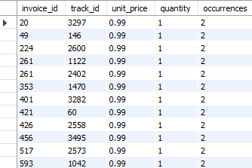

- The analysis of the playlist table revealed that several playlist names are duplicated, even though their id remains unique.
Specifically, the names Music, Movies, TV Shows, and Audiobooks each appear twice, indicating that the same name has been assigned to different playlists. While this does not violate database integrity (since the primary key remains unique), it may lead to confusion in reporting or user-facing applications. These duplicates should be reviewed to determine if they are intentional (e.g., representing different versions or contexts of the same playlist) or if they should be consolidated for consistency.
- 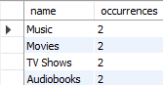
- No other table in the database shows duplicates on
business-relevant columns, so this seems acceptable given the sample nature of the data.

- Find the top-selling tracks and top artists in the USA and identify their most famous genres.
Answer

Query
-- Creating a View for sales corresponding to USA CREATE VIEW usa_sales AS
SELECT il.invoice_line_id,
i.invoice_id, i.billing_country, il.track_id, il.unit_price, il.quantity,
t.name AS track_name, t.genre_id, al.album_id, al.artist_id,
ar.name AS artist_name, g.name AS genre_name
FROM invoice_line il
JOIN invoice i ON il.invoice_id = i.invoice_id JOIN track t ON il.track_id = t.track_id
JOIN album al ON t.album_id = al.album_id JOIN artist ar ON al.artist_id = ar.artist_id JOIN genre g ON t.genre_id = g.genre_id WHERE i.billing_country = 'USA'

-- Top selling tracks in USA WITH
top_tracks AS (
SELECT track_id, track_name,
SUM(quantity) AS total_quantity, SUM(unit_price * quantity) AS total_sales,
DENSE_RANK() OVER(ORDER BY SUM(unit_price * quantity) DESC) AS track_rank FROM usa_sales
GROUP BY track_id, track_name
)
SELECT * FROM top_tracks WHERE track_rank <= 3

-- Top artists in USA WITH
top_artists AS (
SELECT artist_id, artist_name,
SUM(quantity) AS total_quantity, SUM(unit_price * quantity) AS total_sales,
DENSE_RANK() OVER(ORDER BY SUM(unit_price * quantity) DESC) AS artist_rank FROM usa_sales
GROUP BY artist_id, artist_name
)
SELECT * FROM top_artists WHERE artist_rank <=5

-- Most famous genres of top artist WITH
top_artists AS (
SELECT artist_id,
DENSE_RANK() OVER(ORDER BY SUM(unit_price * quantity) DESC) AS artist_rank FROM usa_sales
GROUP BY artist_id
),
top_artist_selection AS (
SELECT artist_id FROM top_artists WHERE artist_rank <=5
),
top_artist_genre AS (
SELECT artist_id, artist_name, genre_name,
SUM(quantity) AS total_quantity, SUM(unit_price * quantity) AS total_sales,
RANK() OVER(PARTITION BY artist_id ORDER BY SUM(unit_price * quantity) DESC) AS genre_rank FROM usa_sales
WHERE artist_id IN (SELECT * FROM top_artist_selection) GROUP BY artist_id, artist_name, genre_name
)
SELECT artist_id, artist_name, genre_name, total_quantity, total_sales FROM top_artist_genre
WHERE genre_rank = 1 ORDER BY total_sales DES;

Output
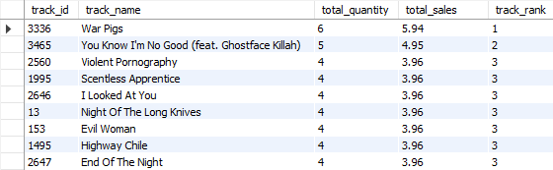
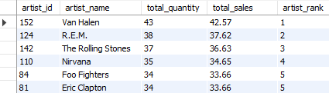
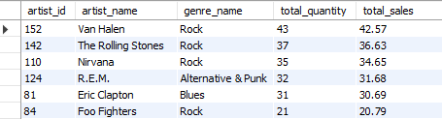

- What is the customer demographic breakdown (age, gender, location) of Chinook's customer base?
Answer

Query
-- Total customers
SELECT COUNT(customer_id) AS customer_count FROM customer

-- Customers by country
SELECT country, COUNT(*) AS customers_count FROM customer
GROUP BY country
ORDER BY customers_count DESC

-- Customers by country & state
SELECT country, state, COUNT(*) AS customers_count FROM customer
GROUP BY country, state
ORDER BY customers_count DESC

-- Customers by country, state, and city
SELECT country, state, city, COUNT(*) AS customers_count FROM customer
GROUP BY country, state, city ORDER BY customers_count DESC

Output
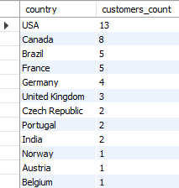
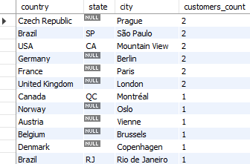

- The customer demographic breakdown of Chinook’s customer base is primarily defined by their geographical location, as the database does not include age or gender information.
- Out of the 59 customers, the majority are concentrated in the USA, followed by significant numbers in Canada, Brazil and France, with smaller clusters in several other countries.
- Within these countries, customers are distributed across various states and cities, reflecting a diverse and international customer base.
- This location-based segmentation provides an opportunity to tailor marketing strategies and promotions according to regional preferences and concentrations.

4. Calculate the total revenue and number of invoices for each country, state and
city.

Answer

Query
    - By Country
SELECT billing_country AS country, COUNT(*) AS invoice_count, SUM(total) AS total_revenue
FROM invoice
GROUP BY billing_country ORDER BY total_revenue DESC;

-- By Country and state
SELECT billing_country AS country, billing_state AS state,
COUNT(*) AS invoice_count, SUM(total) AS total_revenue
FROM invoice
GROUP BY billing_country, billing_state ORDER BY total_revenue DESC;

-- By Country, state and city SELECT billing_country AS country,
billing_state AS state, billing_city AS city, COUNT(*) AS invoice_count, SUM(total) AS total_revenue
FROM invoice
GROUP BY billing_country, billing_state, billing_city ORDER BY total_revenue DESC;

Output
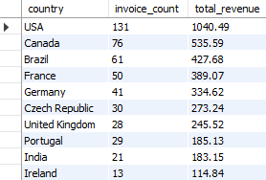
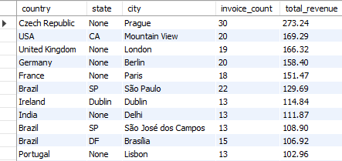

- The USA leads Chinook’s customer base with the highest revenue of
$1,040.49 from 131 invoices, followed by Canada and Brazil with notable contributions of $535.59 and $427.68, respectively.
- At the country & state level, the USA’s California and Washington stand out among specific states, while São Paulo in Brazil and Ontario in Canada also show strong sales figures.
- When further drilled down to the city level, Prague (Czech Republic) emerges as the single most lucrative city with $273.24 from 30 invoices, followed by key cities like Mountain View (California, USA), London (UK), Berlin (Germany), Paris (France), and São Paulo (Brazil).
- These insights highlight that while the USA dominates overall, certain cities and regions outside the USA also contribute significantly, indicating diverse customer engagement across global locations.

5. Find the top 5 customers by total revenue in each country.
Answer

Query
WITH customer_revenue AS ( SELECT c.customer_id,
CONCAT(c.first_name, ' ', c.last_name) AS customer_name, c.country,
SUM(i.total) AS total_revenue,
DENSE_RANK() OVER (PARTITION BY c.country ORDER BY SUM(i.total) DESC) AS revenue_rank FROM customer c
JOIN invoice i ON c.customer_id = i.customer_id GROUP BY c.customer_id, customer_name, c.country
)
SELECT country, customer_id, customer_name, total_revenue, revenue_rank FROM customer_revenue
WHERE revenue_rank <= 5 ORDER BY country, revenue_rank;

Output
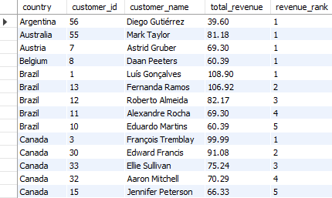

- The analysis of the top 5 customers by total revenue in each country provides valuable insights into Chinook’s most important clientele across different regions.
- In each country, a small group of customers accounts for a significant share of sales, underscoring the importance of identifying and retaining these high-value individuals.
- The rankings show which customers consistently generate the highest revenue within their country, enabling Chinook to tailor loyalty programs, exclusive offers, and personalized communication to these segments.
- Moreover, understanding the distribution of top customers geographically allows the business to identify patterns, such as countries where revenue is more concentrated among a few customers versus countries with a more distributed customer base.
- These insights can guide strategic decisions on where to focus customer relationship management efforts, develop premium services, and allocate marketing resources to maximize returns from these priority customer segments.

6. Identify the top-selling track for each customer.

Answer

Query
    - Top selling track
WITH customer_tracks AS ( SELECT c.customer_id,
CONCAT(c.first_name, ' ', c.last_name) AS customer_name, t.track_id,
t.name AS track_name, SUM(il.quantity) AS total_quantity,
SUM(il.unit_price * il.quantity) AS total_revenue,
RANK() OVER (PARTITION BY c.customer_id ORDER BY SUM(il.unit_price * il.quantity) DESC) AS track_rank FROM customer c
JOIN invoice i ON c.customer_id = i.customer_id JOIN invoice_line il ON i.invoice_id = il.invoice_id JOIN track t ON il.track_id = t.track_id
GROUP BY c.customer_id, customer_name, t.track_id, t.name
)
SELECT customer_id, customer_name, track_id, track_name, total_quantity, total_revenue FROM customer_tracks
WHERE track_rank = 1 ORDER BY customer_id;

-- Top selling genre
WITH customer_genres AS ( SELECT c.customer_id,
CONCAT(c.first_name, ' ', c.last_name) AS customer_name, g.genre_id,
g.name AS genre_name, SUM(il.quantity) AS total_quantity,
SUM(il.unit_price * il.quantity) AS total_revenue,
RANK() OVER (PARTITION BY c.customer_id ORDER BY SUM(il.quantity) DESC) AS genre_rank FROM customer c
JOIN invoice i ON c.customer_id = i.customer_id JOIN invoice_line il ON i.invoice_id = il.invoice_id JOIN track t ON il.track_id = t.track_id
JOIN genre g ON t.genre_id = g.genre_id
GROUP BY c.customer_id, customer_name, g.genre_id, g.name
)
SELECT customer_id, customer_name, genre_name, total_quantity, total_revenue FROM customer_genres
WHERE genre_rank = 1 ORDER BY customer_id;

-- Top selling artist
WITH customer_artists AS ( SELECT c.customer_id,
CONCAT(c.first_name, ' ', c.last_name) AS customer_name, a.artist_id,
a.name AS artist_name, SUM(il.quantity) AS total_quantity,
SUM(il.unit_price * il.quantity) AS total_revenue,
RANK() OVER (PARTITION BY c.customer_id ORDER BY SUM(il.quantity) DESC) AS artist_rank FROM customer c
JOIN invoice i ON c.customer_id = i.customer_id JOIN invoice_line il ON i.invoice_id = il.invoice_id JOIN track t ON il.track_id = t.track_id
JOIN album al ON t.album_id = al.album_id JOIN artist a ON al.artist_id = a.artist_id
GROUP BY c.customer_id, customer_name, a.artist_id, a.name
)
SELECT customer_id, customer_name, artist_name, total_quantity, total_revenue FROM customer_artists
WHERE artist_rank = 1 ORDER BY customer_id;

Output
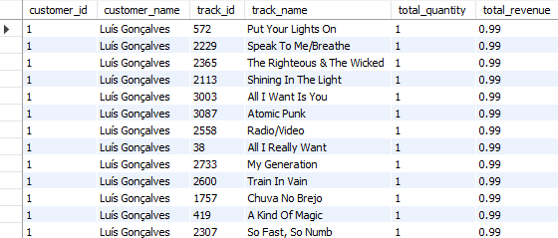
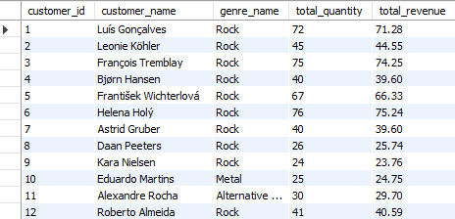
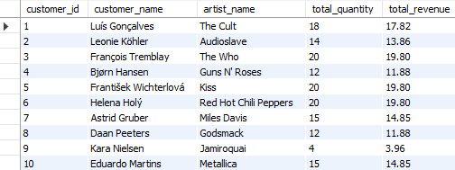

  - In the Chinook dataset, each customer seems to have purchased each track only once (i.e., no customer has bought the same track multiple times).
  - This means that when you group by customer_id and track_id, the SUM(quantity) is always 1, and the total_revenue simply equals the track price.
  - Since no customer shows a preference for a track by buying it repeatedly, identifying the “top” track per customer is effectively just picking one of the tracks they bought, which doesn’t indicate any real preference or behavior.
  - In reality, such analysis is useful if customers have bought multiple tracks and some tracks multiple times, signaling popularity, loyalty, or preference.
  - Instead of identifying a customer’s top-selling track (since all are unique), it would be more insightful to explore their preferred genres and artists.
  - Each customer tends to favor a specific genre, with Rock emerging as the most common favorite across the customer base.
  - Similarly, each of the customers show loyalty to certain artists.
  - These insights into customer-level preferences for genres and artists provide an opportunity to personalize marketing, curate targeted playlists, and design promotions that resonate with each customer’s unique tastes, thereby enhancing engagement and retention.
7. Are there any patterns or trends in customer purchasing behavior (e.g., frequency of purchases, preferred payment methods, average order value)?
Answer

Query
-- Total purchases, AOV, Total spent SELECT c.customer_id,
CONCAT(c.first_name, ' ', c.last_name) AS customer_name, COUNT(i.invoice_id) AS total_purchases,
AVG(i.total) AS avg_order_value, SUM(i.total) AS total_spent
FROM customer c
JOIN invoice i ON c.customer_id = i.customer_id GROUP BY c.customer_id, customer_name ORDER BY total_purchases DESC;

-- Purchase Frequency: Avg gap, Min gap, Max gap WITH customer_invoices AS (
SELECT
customer_id, invoice_date,
LAG(invoice_date) OVER (PARTITION BY customer_id ORDER BY invoice_date) AS prev_invoice_date FROM invoice
),
gaps AS ( SELECT
customer_id,
DATEDIFF(invoice_date, prev_invoice_date) AS gap_days FROM customer_invoices
WHERE prev_invoice_date IS NOT NULL
) SELECT
c.customer_id,
CONCAT(c.first_name, ' ', c.last_name) AS customer_name, AVG(g.gap_days) AS avg_gap_days,
MIN(g.gap_days) AS min_gap_days, MAX(g.gap_days) AS max_gap_days
FROM gaps g
JOIN customer c ON g.customer_id = c.customer_id GROUP BY c.customer_id, customer_name
ORDER BY c.customer_id;

Output
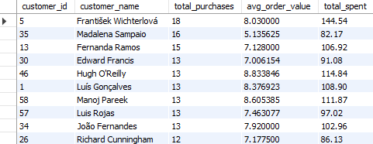
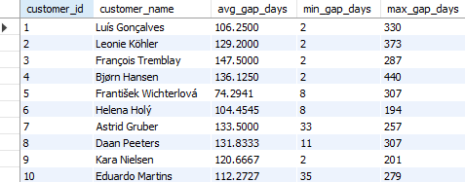

- Total Purchases, AOV and Total Spent
  - The purchasing patterns of Chinook’s customers show a strong concentration of moderate-frequency buyers with steady spending habits.
  - The majority of customers make between 8–13 purchases, with average order values (AOV) consistently between $7–$9 per invoice, reflecting uniform pricing and buying behavior.
  - Notably, some customers, such as Robert Brown, stand out for having high AOVs despite fewer purchases, indicating premium spending tendencies.
  - Overall, these insights suggest a stable and predictable customer base, with opportunities to further engage high-AOV customers and encourage more frequent purchases from lower-frequency segments.
- Purchase Frequency
  - The analysis of purchase frequency, measured as the average, minimum, and maximum gap (in days) between consecutive purchases, reveals considerable variation across customers.
  - Most customers exhibit an average gap of around 100–150 days, indicating fairly infrequent, periodic buying behavior.
  - The minimum gap for many customers is as low as 1–8 days, showing occasional bursts of activity, whereas maximum gaps can stretch to over 900 days in extreme cases, highlighting periods of inactivity.
  - These insights point to a predominantly irregular purchasing pattern, with opportunities to engage customers more consistently and reduce the long dormant periods between purchases.

8. What is the customer churn rate?

Answer

Query
WITH last_purchase AS (
SELECT customer_id, MAX(invoice_date) AS last_invoice_date FROM invoice
GROUP BY customer_id
)

SELECT
COUNT(*) AS total_customers,

SUM(CASE WHEN last_invoice_date < '2020-10-01' THEN 1 ELSE 0 END) AS churned_3m, chCurOnN_CraAteT_(R3mO,UND(SUM(CASE WHEN last_invoice_date < '2020-10-01' THEN 1 ELSE 0 END) / COUNT(*) * 100, 2), '%') AS

SUM(CASE WHEN last_invoice_date < '2020-07-01' THEN 1 ELSE 0 END) AS churned_6m, chCurOnN_CraAteT_(R6mO,UND(SUM(CASE WHEN last_invoice_date < '2020-07-01' THEN 1 ELSE 0 END) / COUNT(*) * 100, 2), '%') AS

SUM(CASE WHEN last_invoice_date < '2020-01-01' THEN 1 ELSE 0 END) AS churned_12m, chCurOnN_CraAteT_(R12OmUND(SUM(CASE WHEN last_invoice_date < '2020-01-01' THEN 1 ELSE 0 END) / COUNT(*) * 100, 2), '%') AS

FROM last_purchase;

Output

- Since most of the last invoices for customers were dated during the last quarter of 2020, we assume that this analysis was conducted as of
31-Dec-2020, making it a reasonable cutoff point for evaluating customer activity and churn.
- Over the preceding 3 months, 37.29% (22 out of 59) of customers had not made a purchase, indicating a significant short-term drop-off.
- At the 6-month mark, churn improved slightly, with 27.12% (16 customers) inactive, and over the 12-month period, churn was very low at just 1.69% (1 customer).
- This suggests that while some customers lapse temporarily, many remain engaged over the long term, and targeted strategies to
re-engage short-term inactive customers could help further improve retention.
9. Calculate the percentage of total sales contributed by each genre in the USA and identify the best-selling genres and artists.
Answer

Query
-- Genre level sales in USA WITH usa_sales AS (
SELECT il.invoice_line_id, il.unit_price, il.quantity, i.billing_country, t.genre_id, g.name AS genre_name, al.artist_id, ar.name AS artist_name
FROM invoice_line il
JOIN invoice i ON il.invoice_id = i.invoice_id JOIN track t ON il.track_id = t.track_id
JOIN genre g ON t.genre_id = g.genre_id JOIN album al ON t.album_id = al.album_id JOIN artist ar ON al.artist_id = ar.artist_id WHERE i.billing_country = 'USA'
),
genre_sales AS ( SELECT genre_name,
SUM(unit_price * quantity) AS genre_revenue FROM usa_sales
GROUP BY genre_name
),
total_usa_sales AS (
SELECT SUM(unit_price * quantity) AS total_revenue FROM usa_sales
)
SELECT gs.genre_name, gs.genre_revenue,
ROUND(gs.genre_revenue / tus.total_revenue * 100, 2) AS percent_of_usa_sales FROM genre_sales gs
CROSS JOIN total_usa_sales tus ORDER BY gs.genre_revenue DESC;

Output
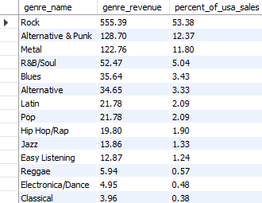

- In the USA, the Rock genre overwhelmingly dominates the music sales, contributing $555.39 and accounting for approximately 53.38% of total revenue.
- This is followed by Alternative & Punk at 12.37%, and Metal at
11.80%, making these the top three genres by sales.
- Other notable genres include R&B/Soul, Blues, and Alternative, each contributing between 3–5% of revenue.
- This clear preference for Rock and related genres suggests that marketing and inventory strategies in the USA should emphasize these categories while exploring ways to grow engagement in niche genres.
- The best selling artists have been identified earlier in Q2.

10. Find customers who have purchased tracks from at least 3 different genres.

Answer

Query
WITH customer_genre_count AS ( SELECT c.customer_id,
CONCAT(c.first_name, ' ', c.last_name) AS customer_name, COUNT(DISTINCT t.genre_id) AS genre_count
FROM customer c
JOIN invoice i ON c.customer_id = i.customer_id JOIN invoice_line il ON i.invoice_id = il.invoice_id JOIN track t ON il.track_id = t.track_id
GROUP BY c.customer_id, customer_name
)
SELECT customer_id, customer_name, genre_count FROM customer_genre_count
WHERE genre_count >= 3 ORDER BY genre_count DESC;

Output
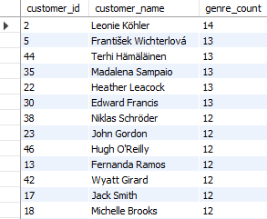
- The analysis reveals that all customers purchased tracks from at least 5 different genres, highlighting a strong tendency toward diverse musical tastes across the entire customer base.
- At the top, Leonie Köhler engaged with 14 genres, followed closely by František Wichterlová, Terhi Hämäläinen, and others exploring 12–13 genres each.
- Even the customer with the fewest genres, Robert Brown, still interacted with 5 genres, indicating that customers do not restrict themselves to a single or narrow set of genres.
- This widespread diversity presents an opportunity to engage customers with cross-genre marketing campaigns, curated multi-genre playlists, and recommendations that cater to their exploratory behavior and openness to variety.

11. Rank genres based on their sales performance in the USA.

Answer

Query
WITH usa_genre_sales AS ( SELECT g.genre_id,
g.name AS genre_name,
SUM(il.unit_price * il.quantity) AS total_sales FROM invoice_line il
JOIN invoice i ON il.invoice_id = i.invoice_id JOIN track t ON il.track_id = t.track_id
JOIN genre g ON t.genre_id = g.genre_id WHERE i.billing_country = 'USA' GROUP BY g.genre_id, g.name
)
SELECT genre_name, total_sales,
DENSE_RANK() OVER (ORDER BY total_sales DESC) AS genre_rank FROM usa_genre_sales
ORDER BY genre_rank;

Output
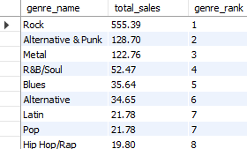
- The ranking of genres by sales performance in the USA confirms the overwhelming dominance of Rock, which secured the top position with
$555.39 in sales.
- Following at a distance are Alternative & Punk and Metal, with
$128.70 and $122.76 respectively, ranking second and third.
- Genres like R&B/Soul, Blues, and Alternative fill the middle ranks, while Latin and Pop share the seventh place with identical sales.
- The lower ranks are occupied by niche genres such as Jazz, Easy Listening, Reggae, and others, with TV Shows recording the smallest contribution at $0.99.
- This distribution underscores the enduring popularity of Rock and related genres in the USA, while also highlighting opportunities to grow sales in underrepresented genres through targeted promotions and curated offerings.

12. Identify customers who have not made a purchase in the last 3 months.

Answer

Query
WITH last_purchase AS ( SELECT c.customer_id,
CONCAT(c.first_name, ' ', c.last_name) AS customer_name, MAX(i.invoice_date) AS last_invoice_date
FROM customer c
LEFT JOIN invoice i ON c.customer_id = i.customer_id GROUP BY c.customer_id, customer_name
)
SELECT customer_id, customer_name, last_invoice_date FROM last_purchase
WHERE last_invoice_date < '2020-10-01' OR last_invoice_date IS NULL ORDER BY last_invoice_date;

Output
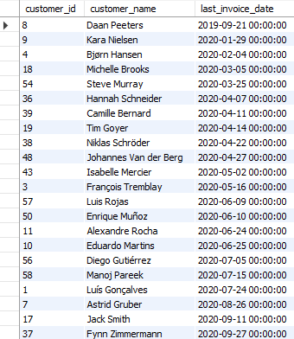

- Since most of the last invoices for customers were dated during the last quarter of 2020, we assume that this analysis was conducted as of
31-Dec-2020, making it a reasonable cutoff point for evaluating customer activity
- As of 31-Dec-2020, a total of 22 customers have not made a purchase in the preceding three months, making them potential churn risks.
- Their last purchase dates range from as far back as September 2019
(Daan Peeters) to as recent as September 2020 (Fynn Zimmermann).
- Notably, customers such as Kara Nielsen, Bjørn Hansen, and Michelle Brooks have been inactive for nearly the entire year, suggesting a higher likelihood of churn, while others like Jack Smith and Fynn Zimmermann have lapsed only recently.
- These customers represent a key segment for re-engagement initiatives, offering an opportunity to bring them back through targeted promotions, personalized outreach, or loyalty programs.

Subjective Questions
- Recommend the three albums from the new record label that should be prioritised for advertising and promotion in the USA based on genre sales analysis.
Answer

Reference
    - In the USA, previous analysis showed the top genres were:
      - Rock (53.38 percent of sales)
      - Alternative and Punk (12.37 percent)
      - Metal (11.80 percent)
- Goal is to align promotional efforts with these genre preferences in the USA.
- No specific list of albums from the new record label is provided, so we assume that all albums in the album table represent the new record label’s catalog.

Approach
    - Use the album table as the new record label catalog.
    - Dynamically determine the top 3 genres by total USA sales.
    - Identify which albums from the new record label belong to the top-selling genres in the USA.
    - Rank these albums based on their genre alignment with USA preferences.
    - Recommend one album from each of these genres for promotion.

Query
WITH usa_genre_sales AS ( SELECT g.genre_id,
g.name AS genre_name,
SUM(il.unit_price * il.quantity) AS genre_sales_usa FROM invoice_line il
JOIN invoice i ON il.invoice_id = i.invoice_id JOIN track t ON il.track_id = t.track_id
JOIN genre g ON t.genre_id = g.genre_id WHERE i.billing_country = 'USA' GROUP BY g.genre_id, g.name
),
top_3_genres AS (
SELECT genre_id, genre_name FROM usa_genre_sales
ORDER BY genre_sales_usa DESC LIMIT 3
),
usa_album_sales AS ( SELECT al.album_id,
al.title AS album_title, g.genre_id,
g.name AS genre_name,
SUM(il.unit_price * il.quantity) AS total_sales_usa FROM album al
JOIN track t ON al.album_id = t.album_id JOIN genre g ON t.genre_id = g.genre_id JOIN invoice_line il ON t.track_id = il.track_id JOIN invoice i ON il.invoice_id = i.invoice_id
WHERE i.billing_country = 'USA'
AND g.genre_id IN (SELECT genre_id FROM top_3_genres) GROUP BY al.album_id, al.title, g.genre_id, g.name
),
ranked_albums AS ( SELECT *,
ROW_NUMBER() OVER (PARTITION BY genre_name ORDER BY total_sales_usa DESC) AS rn FROM usa_album_sales
)
SELECT album_title, genre_name, total_sales_usa FROM ranked_albums
WHERE rn = 1
ORDER BY total_sales_usa DESC;

Output
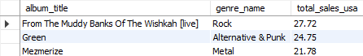
- Insights
  - Rock continues to dominate USA sales, making From The Muddy Banks Of The Wishkah [live] an ideal lead album for promotion.
  - Green captures the strong Alternative & Punk audience, appealing to a passionate niche segment.
  - Mezmerize leads Metal sales and taps into loyal listeners of heavier music.
  - Together, these three albums align perfectly with the most popular genres in the USA, maximizing reach and engagement.

Suggestions
  - Prioritize these three albums in the USA promotional campaign.
  - Position them in advertising, featured playlists, and special bundles targeted to USA audiences.
  - Monitor campaign response to adjust promotion intensity by genre if needed.

- Determine the top-selling genres in countries other than the USA and identify any commonalities or differences.
Answer

Reference
    - In the USA, previous analysis showed the top genres were:
      - Rock (53.38 percent of sales)
      - Alternative and Punk (12.37 percent)
      - Metal (11.80 percent)
    - The goal here is to analyze customers from all other countries to see if they prefer the same genres or if their preferences differ.

Approach
    - Consider only invoices where the billing country is not the USA.
    - Link these invoices to the invoice details and the tracks purchased, and identify the genre of each track.
    - Calculate the total sales for each genre from these non-USA invoices.
    - Rank the genres by their total sales in descending order.
    - Compare the ranked list of genres outside the USA to the previously found list for the USA.
    - Identify which genres are common across regions and which genres are more prominent outside the USA.

Query
WITH genre_sales_non_usa AS ( SELECT g.name AS genre_name,
SUM(il.unit_price * il.quantity) AS total_sales FROM invoice i
JOIN invoice_line il ON i.invoice_id = il.invoice_id JOIN track t ON il.track_id = t.track_id
JOIN genre g ON t.genre_id = g.genre_id WHERE i.billing_country != 'USA' GROUP BY g.name
)
SELECT genre_name, total_sales,
DENSE_RANK() OVER (ORDER BY total_sales DESC) AS genre_rank FROM genre_sales_non_usa
ORDER BY genre_rank;

Output
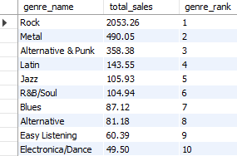

- Insights
  - Rock remains the highest-selling genre outside the USA, showing its broad global appeal.
  - Classical, Jazz, and Latin rank higher outside the USA than inside, suggesting stronger regional preferences for these styles.
  - Rock is a common favorite globally, maintaining its top rank both inside and outside the USA.
  - A key difference is that non-USA markets show more interest in Classical and Jazz compared to USA customers.

Suggestions
  - Maintain Rock as the primary genre to promote globally, given its consistent popularity.
  - Include Classical and Jazz in marketing campaigns aimed at customers outside the USA, where these genres perform well.
  - Create advertising, playlists, and promotions that reflect both global favorites and local tastes, to increase engagement and sales in international markets.

- Customer Purchasing Behavior Analysis: How do the purchasing habits (frequency, basket size, spending amount) of long-term customers differ from those of new customers? What insights can these patterns provide about customer loyalty and retention strategies?
Answer

Reference
    - Definitions assumed:
      - Long-term customers: Customers who made their first purchase more than a year ago as of 31-Dec-2020.
      - New customers: Customers who made their first purchase within the last year.
    - There are no truly "new customers" in this dataset as of 31-Dec-2020, since everyone started at least 2–3 years earlier.
    - To still analyze customer loyalty and behavior meaningfully, lets redefine the categories based on recency
      - Active: last purchase in the last 6 months of 2020
      - Dormant: last purchase before July 2020
    - Metrics analyzed:
      - Purchase frequency (number of invoices per customer)
      - Basket size (average number of tracks per invoice)
      - Spending amount (total and average revenue per customer and per invoice)

Approach
    - Find the most recent purchase date for each customer.
    - Classify customers as active or dormant based on the last purchase date.
    - For each group:
      - Calculate the average number of invoices per customer.
      - Calculate the average number of tracks per invoice (basket size).
      - Calculate total and average spending.
    - Compare these metrics between long-term and new customers.
    - Interpret the differences to draw conclusions about loyalty and retention.

Query
WITH last_purchase AS ( SELECT c.customer_id,
CONCAT(c.first_name, ' ', c.last_name) AS customer_name, MAX(i.invoice_date) AS last_invoice_date
FROM customer c
JOIN invoice i ON c.customer_id = i.customer_id GROUP BY c.customer_id, customer_name
),
customer_status AS ( SELECT lp.customer_id,
lp.customer_name, lp.last_invoice_date, CASE
WHEN lp.last_invoice_date >= '2020-07-01' THEN 'Active' ELSE 'Dormant'
END AS status FROM last_purchase lp
),
customer_metrics AS ( SELECT cs.status,
cs.customer_id,
COUNT(DISTINCT i.invoice_id) AS invoice_count, SUM(il.quantity) AS total_tracks,
SUM(i.total) AS total_spent FROM customer_status cs
JOIN invoice i ON cs.customer_id = i.customer_id JOIN invoice_line il ON i.invoice_id = il.invoice_id GROUP BY cs.status, cs.customer_id
) SELECT
status,
COUNT(*) AS customer_count,
ROUND(AVG(invoice_count), 2) AS avg_frequency_per_customer, ROUND(AVG(total_tracks / invoice_count), 2) AS avg_basket_size, ROUND(AVG(total_spent), 2) AS avg_spent_per_customer, ROUND(SUM(total_spent), 2) AS total_spent_group
FROM customer_metrics GROUP BY status;

Output

- Insights
  - Active customers make purchases slightly more frequently (10.6 vs 9.88 invoices on average).
  - Active customers also have a marginally larger basket size (7.89 vs 7.70 tracks per invoice).
  - Active customers spend significantly more per customer (839.82 vs 711.93) and contribute more than three times the total revenue compared to dormant customers.
  - These results show that active customers are more engaged, more frequent, and more valuable in total spending.

Suggestions
  - Focus on maintaining and rewarding Active customers to sustain their higher engagement and spending.
  - Target Dormant customers with win-back campaigns, personalized promotions, or incentives to encourage them to return.
  - Monitor dormant customers with historically high spending to prioritize reactivation efforts.
  - Consider loyalty programs that further increase purchase frequency and basket size among Active customers.
- Visualisation
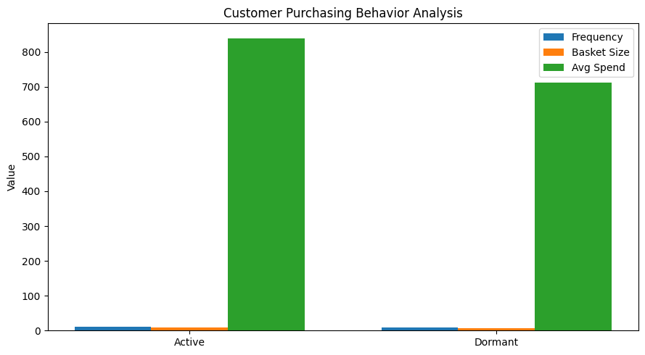

Key Takeaway
Active customers generate higher revenue and slightly stronger purchasing activity, but Dormant customers exhibit similar shopping behavior. This suggests that effective customer retention and win-back strategies can have a significant positive impact on business performance.

- Product Affinity Analysis: Which music genres, artists, or albums are frequently purchased together by customers? How can this information guide product recommendations and cross-selling initiatives?
Answer

Reference
    - Objective: To identify pairs of genres, artists, and albums that often appear together in customer purchases and use these insights for product recommendations and cross-selling.

Approach
    - Treat each invoice as a “basket” of purchased tracks.
    - For each invoice, identify all distinct pairs of genres, artists, and albums purchased together.
    - Aggregate across all invoices to count how many times each pair appears.
    - Rank the pairs by their co-occurrence count to find the strongest affinities.
    - Use the results to identify which genres, artists, and albums should be recommended together.

Query
-- Frequently Bought Together: GENRES WITH invoice_genres AS (
SELECT i.invoice_id, g.name AS genre_name FROM invoice i
JOIN invoice_line il ON i.invoice_id = il.invoice_id JOIN track t ON il.track_id = t.track_id
JOIN genre g ON t.genre_id = g.genre_id GROUP BY i.invoice_id, g.name
),
genre_pairs AS (
SELECT ig1.genre_name AS genre_1, ig2.genre_name AS genre_2, COUNT(*) AS pair_count
FROM invoice_genres ig1 JOIN invoice_genres ig2
ON ig1.invoice_id = ig2.invoice_id AND ig1.genre_name < ig2.genre_name GROUP BY ig1.genre_name, ig2.genre_name
)
SELECT genre_1, genre_2, pair_count FROM genre_pairs
ORDER BY pair_count DESC LIMIT 10;

-- Frequently Bought Together: ARTISTS WITH invoice_artists AS (
SELECT i.invoice_id, ar.name AS artist_name FROM invoice i
JOIN invoice_line il ON i.invoice_id = il.invoice_id JOIN track t ON il.track_id = t.track_id
JOIN album al ON t.album_id = al.album_id JOIN artist ar ON al.artist_id = ar.artist_id GROUP BY i.invoice_id, ar.name
),
artist_pairs AS (
SELECT ia1.artist_name AS artist_1, ia2.artist_name AS artist_2, COUNT(*) AS pair_count
FROM invoice_artists ia1 JOIN invoice_artists ia2
ON ia1.invoice_id = ia2.invoice_id AND ia1.artist_name < ia2.artist_name GROUP BY ia1.artist_name, ia2.artist_name
)
SELECT artist_1, artist_2, pair_count FROM artist_pairs
ORDER BY pair_count DESC LIMIT 10;

-- Frequently Bought Together: ALBUMS WITH invoice_albums AS (
SELECT i.invoice_id, al.title AS album_title FROM invoice i
JOIN invoice_line il ON i.invoice_id = il.invoice_id JOIN track t ON il.track_id = t.track_id
JOIN album al ON t.album_id = al.album_id GROUP BY i.invoice_id, al.title
),
album_pairs AS (
SELECT ia1.album_title AS album_1, ia2.album_title AS album_2, COUNT(*) AS pair_count
FROM invoice_albums ia1 JOIN invoice_albums ia2
ON ia1.invoice_id = ia2.invoice_id AND ia1.album_title < ia2.album_title GROUP BY ia1.album_title, ia2.album_title
)
SELECT album_1, album_2, pair_count FROM album_pairs
ORDER BY pair_count DESC LIMIT 10;

Output
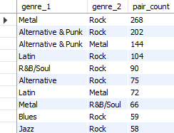
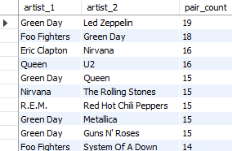

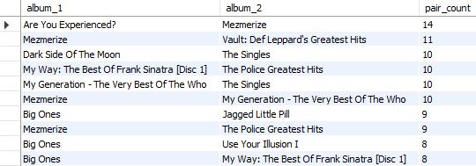

- Insights
  - Rock-related genres dominate the affinity analysis, pairing frequently with Alternative & Punk, Metal, and even Latin and Jazz, showing broad cross-genre appeal.
  - Green Day emerges as a central artist, frequently bought with multiple others such as Led Zeppelin, Foo Fighters, Queen, and Metallica, suggesting strong cross-artist interest.
  - The album Mezmerize appears repeatedly with several other classic albums, indicating it may act as a bridge in customer preferences.
  - Customers tend to buy complementary genres and artists, especially those within the broader Rock and Alternative space, alongside occasional interest in Jazz and Blues.

Suggestions
  - Leverage these affinity insights in product recommendations by suggesting Alternative & Punk and Metal tracks alongside Rock purchases.
Feature Green Day prominently in cross-selling campaigns, highlighting collaborations or similar artists like Foo Fighters and Led Zeppelin.
Bundle albums like Mezmerize, Are You Experienced?, and Vault: Def Leppard's Greatest Hits into curated multi-album offers or playlists.
Incorporate these findings into recommendation engines, curated email marketing campaigns, and store displays to encourage cross-genre and cross-artist purchases.

- Regional Market Analysis: Do customer purchasing behaviors and churn rates vary across different geographic regions or store locations? How might these correlate with local demographic or economic factors?
Answer

Reference
    - Analysis as of: 31-Dec-2020
    - Metrics considered:
      - Average purchase frequency (number of invoices per customer)
      - Average spend per customer
      - Churn rate (%) (percentage of customers whose last purchase was before July 2020)
    - Since the customer sample dataset is small we are considering regional breakdown at the country level.

Approach
    - For each customer, compute total invoices, total spending, and last purchase date.
    - Classify customers in each country as Active or Churned based on their last purchase date (before or after 1-Jul-2020).
    - Aggregate customer-level data by country to compute the required metrics.
    - Compare these metrics across countries to identify regional patterns.

Query
WITH last_purchase AS (
SELECT c.customer_id, c.country, MAX(i.invoice_date) AS last_invoice_date, COUNT(i.invoice_id) AS total_invoices, SUM(i.total) AS total_spent
FROM customer c
JOIN invoice i ON c.customer_id = i.customer_id GROUP BY c.customer_id, c.country
),
customer_status AS ( SELECT lp.country,
CASE WHEN lp.last_invoice_date < '2020-07-01' THEN 'Churned' ELSE 'Active' END AS status, lp.customer_id,
lp.total_invoices, lp.total_spent
FROM last_purchase lp
)
SELECT country,
COUNT(DISTINCT customer_id) AS customer_count, SUM(total_invoices) / COUNT(DISTINCT customer_id) AS avg_frequency,
SUM(total_spent) / COUNT(DISTINCT customer_id) AS avg_spent_per_customer, SUM(CASE WHEN status = 'Churned' THEN 1 ELSE 0 END) / COUNT(*) * 100 AS churn_rate
FROM customer_status GROUP BY country
ORDER BY customer_count DESC;

Output
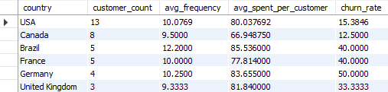

- Insights
  - USA and Canada show healthy engagement, with moderate churn rates (~12–15%) and steady spending.
  - European countries like Germany and France show higher churn (40–50%) despite similar or higher spending, indicating retention challenges.
  - Small countries with only one customer (Belgium, Chile, Denmark, Netherlands, Norway, Spain) exhibit 100% churn, suggesting these customers have not purchased recently.
  - Czech Republic, India, Portugal, Ireland, and others have low churn (0%), with high spending and frequency, suggesting strong loyalty in these regions.

Suggestions
  - Focus retention efforts on European countries with moderate-to-high churn (France, Germany, UK), where customers show good spending but high dropout risk.
  - Re-engage customers in small markets (Belgium, Chile, Denmark, Netherlands, Norway, Spain) with targeted campaigns to recover dormant customers.
  - Maintain engagement in low-churn, high-value regions (Czech Republic, Portugal, India, Ireland) with loyalty programs and personalized offers.
  - Use these regional insights to tailor marketing messages, pricing, and promotions based on local behavior and economic conditions.
- Visualisation
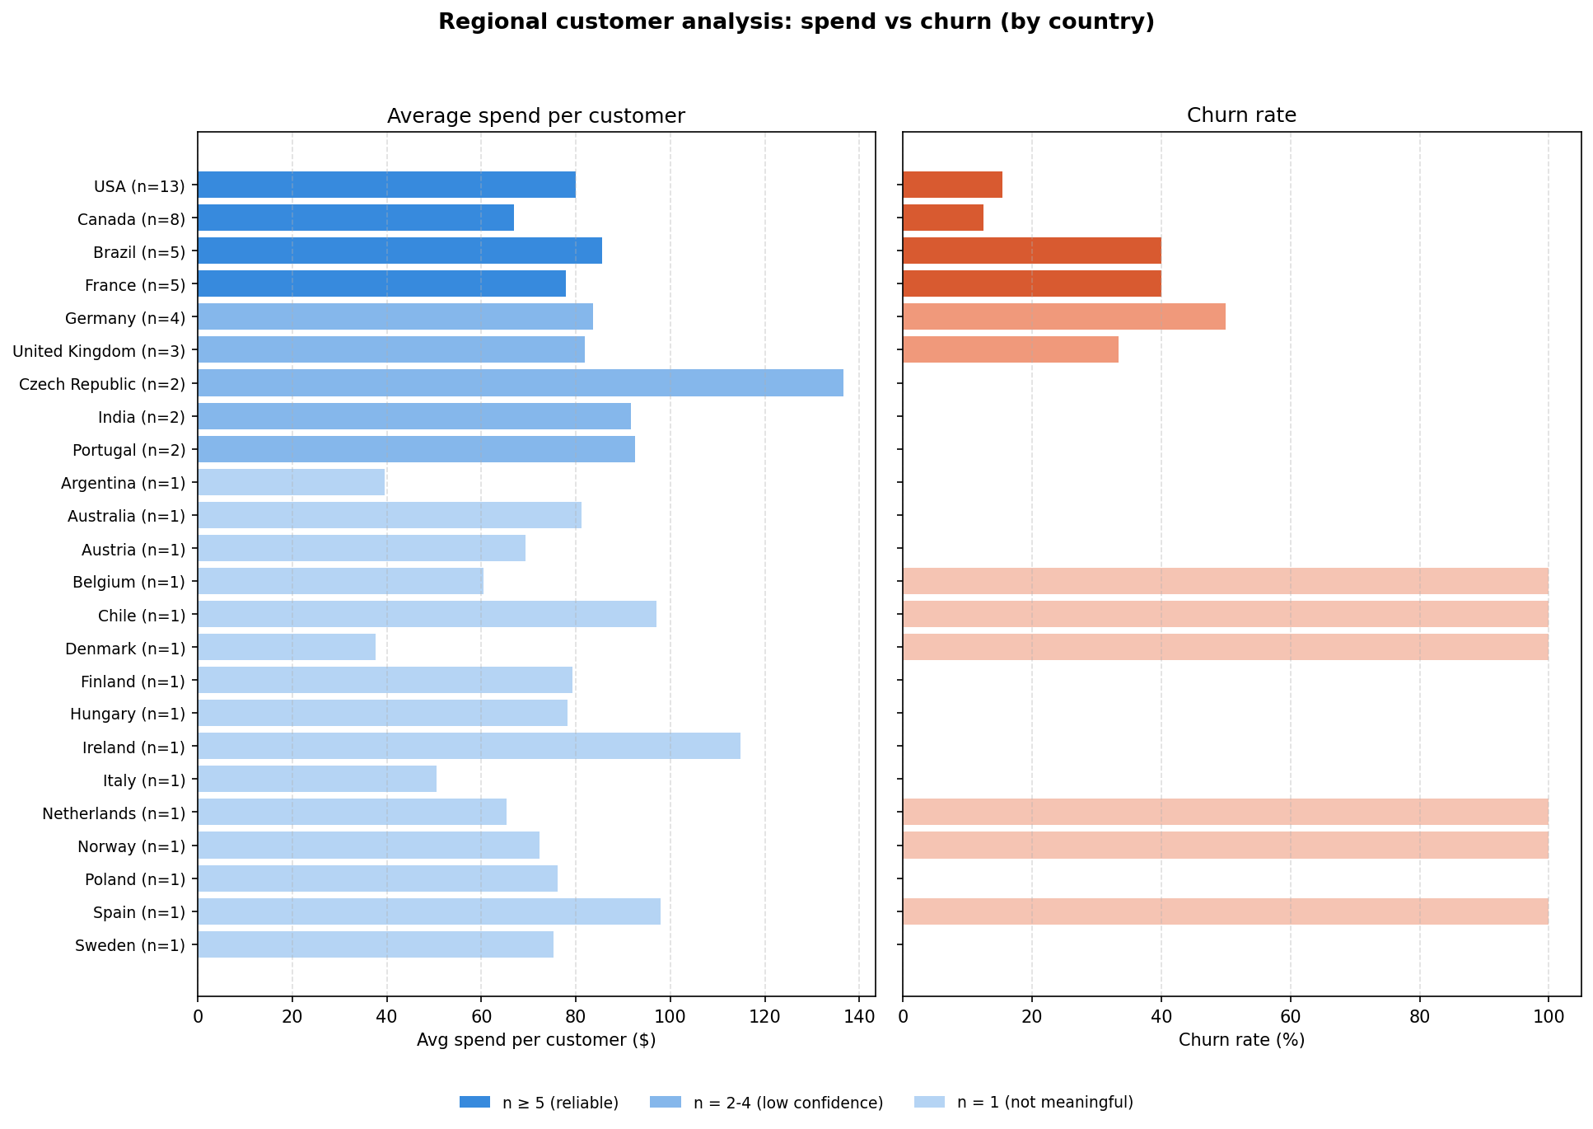

- Customer Risk Profiling: Based on customer profiles (age, gender, location, purchase history), which customer segments are more likely to churn or pose a higher risk of reduced spending? What factors contribute to this risk?
Answer

Reference
    - Analysis date: 31-Dec-2020
    - Metrics considered:
      - Average purchase frequency (number of invoices per customer)
      - Average spend per customer
      - Churn rate (%) (percentage of customers whose last purchase was before July 2020)
    - Segmented by city and country
    - The Chinook dataset does not include age or gender information, so risk profiling here is based on location, purchase frequency, spending and churn behavior.

Approach
    - Classify customers into segments using available profile attributes:
      - Location: country
      - Purchase history: frequency of invoices, recency of last purchase, total spending
    - Define high-risk customers as those with:
      - Last purchase more than 6 months ago (high churn likelihood)
      - Low purchase frequency and low total spending
      - Regions with historically higher churn rates (from earlier regional analysis)
    - Identify which combinations of location and purchase behavior are most associated with churn or reduced engagement.
    - Analyze how these factors contribute to risk to help target retention strategies.

Query
WITH customer_metrics AS ( SELECT c.customer_id, c.country,
MAX(i.invoice_date) AS last_purchase, COUNT(i.invoice_id) AS total_invoices, SUM(i.total) AS total_spent
FROM customer c
JOIN invoice i ON c.customer_id = i.customer_id GROUP BY c.customer_id, c.country
)
SELECT country,
AVG(total_invoices) AS avg_frequency, AVG(total_spent) AS avg_spending,
SUM(CASE WHEN last_purchase < '2020-07-01' THEN 1 ELSE 0 END) / COUNT(*) * 100 AS churn_rate FROM customer_metrics
GROUP BY country
ORDER BY churn_rate DESC, avg_spending ASC;

-- Group by churn 100%, 0% and between both WITH customer_metrics AS (
SELECT c.customer_id, c.country, MAX(i.invoice_date) AS last_purchase, COUNT(i.invoice_id) AS total_invoices, SUM(i.total) AS total_spent
FROM customer c
JOIN invoice i ON c.customer_id = i.customer_id GROUP BY c.customer_id, c.country
),
country_wise_metrics AS ( SELECT country,
AVG(total_invoices) AS avg_frequency, AVG(total_spent) AS avg_spending,
SUM(CASE WHEN last_purchase < '2020-07-01' THEN 1 ELSE 0 END) / COUNT(*) * 100 AS churn_rate FROM customer_metrics
GROUP BY country
ORDER BY churn_rate DESC, avg_spending ASC
),
churn_category AS ( SELECT *,
CASE WHEN churn_rate = 100 THEN "High" WHEN churn_rate > 0 THEN "Medium" ELSE "Low"
END AS churn_category FROM country_wise_metrics
)
SELECT churn_category, AVG(avg_frequency) AS avg_freq, AVG(avg_spending) AS avg_spend, count(*) AS country_count
FROM churn_category GROUP BY churn_category

Output
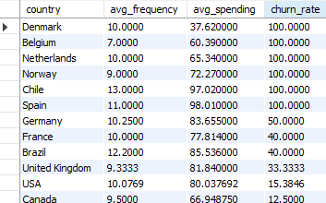
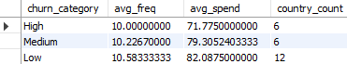

- Insights
  - Customers in smaller markets (Belgium, Chile, Denmark, Netherlands, Norway, Spain) show 100% churn, suggesting higher risk in these regions.
  - Customers in Germany and France exhibit moderate to high churn (40–50%) despite higher average spending, indicating potential engagement or competitive challenges.
  - Customers with low purchase frequency and low total spending in high-churn regions represent the riskiest segments.
  - Customers from locations with high churn and lower economic activity may be more sensitive to pricing or less engaged with the product offering.

Suggestions
  - Prioritize retention efforts on regions with high churn but high spending potential (e.g., Germany, France) by offering loyalty benefits and personalized offers.
  - Target smaller, high-risk regions (e.g., Belgium, Denmark, Chile) with reactivation campaigns to recover lost customers and test promotional incentives.
  - Monitor customers with both low frequency and low spending in
high-churn regions and consider tailored content, discounts, or service improvements to re-engage them.
- Visualisation
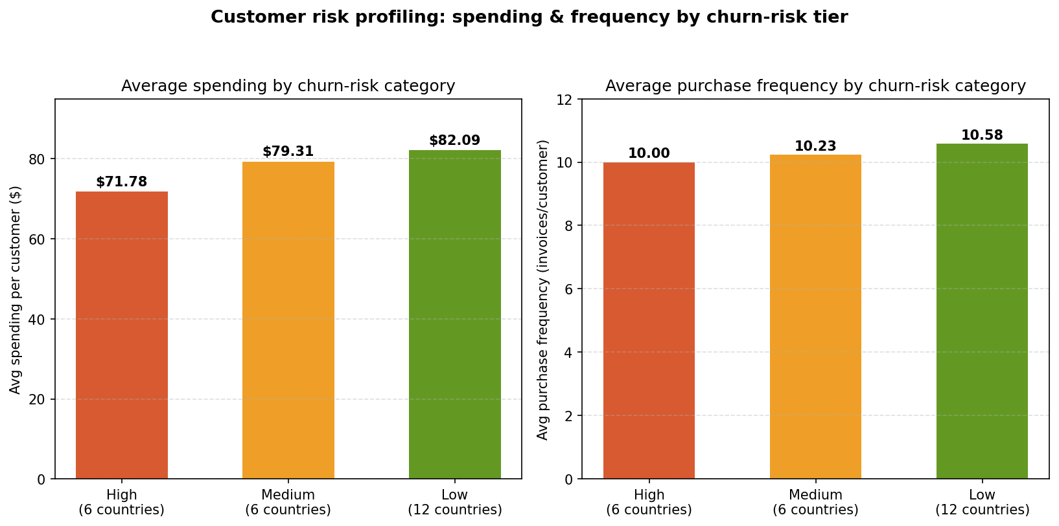

- Customer Lifetime Value Modeling: How can you leverage customer data (tenure, purchase history, engagement) to predict the lifetime value of different customer segments? This could inform targeted marketing and loyalty program strategies. Can you observe any common characteristics or purchase patterns among customers who have stopped purchasing
Answer

Reference
    - Categorize customers into CLV tiers based on a composite score that considers:
      - Tenure days (loyalty / duration)
      - Total invoices (engagement / frequency)
      - Annual revenue (monetary value)
    - This reflects the recency, frequency, and monetary value (RFM-like)
behavior more holistically.

Approach
    - Compute the 3 metrics per customer.
    - Since these three metrics are on different scales, normalize them using NTILE(4) so they’re comparable.
    - Add the normalized scores for the three metrics to get a composite CLV score, then segment customers into tiers based on the total score.
      - High CLV → score ≥ 10
      - Medium CLV → 7–9
      - Low CLV → < 7
    - Within each of these segments identify the percentage of customers that are active and dormant based on 6 month churn.

Query
CREATE OR REPLACE VIEW customer_clv_tier AS WITH customer_history AS (
SELECT c.customer_id,
CONCAT(c.first_name, ' ', c.last_name) AS customer_name, MIN(i.invoice_date) AS first_purchase,
MAX(i.invoice_date) AS last_purchase, DATEDIFF(MAX(i.invoice_date), MIN(i.invoice_date)) AS tenure_days, SUM(i.total) AS total_revenue,
COUNT(i.invoice_id) AS total_invoices,
ROUND(SUM(i.total) / (DATEDIFF(MAX(i.invoice_date), MIN(i.invoice_date)) / 365), 2) AS annual_revenue FROM customer c
JOIN invoice i ON c.customer_id = i.customer_id GROUP BY c.customer_id, customer_name
),
ranked_metrics AS ( SELECT *,
NTILE(4) OVER (ORDER BY tenure_days ASC) AS tenure_rank, NTILE(4) OVER (ORDER BY total_invoices ASC) AS invoice_rank, NTILE(4) OVER (ORDER BY annual_revenue ASC) AS revenue_rank
FROM customer_history
),
composite_score AS ( SELECT *,
(tenure_rank + invoice_rank + revenue_rank) AS total_score FROM ranked_metrics
)
SELECT *
FROM composite_score

-- Customers in each CLV tier SELECT customer_name,
CASE
WHEN total_score >= 10 THEN 'High CLV'
WHEN total_score >= 7 THEN 'Medium CLV' ELSE 'Low CLV'
END AS clv_tier, CASE
WHEN last_purchase < '2020-07-01' THEN 'Churned' ELSE 'Active'
END AS churn FROM customer_clv_tier
ORDER BY clv_tier DESC, customer_name;

-- Percentage of customers active and churned within each CLV tier WITH clv_churn_relation AS (
SELECT customer_name, CASE
WHEN total_score >= 10 THEN 'High CLV' WHEN total_score >= 7 THEN 'Medium CLV' ELSE 'Low CLV'
END AS clv_tier, CASE
WHEN last_purchase < '2020-07-01' THEN 'Churned' ELSE 'Active'
END AS churn FROM customer_clv_tier
),
counts AS (
SELECT clv_tier, churn, COUNT(*) AS customer_count FROM clv_churn_relation
GROUP BY clv_tier, churn
),
totals AS (
SELECT clv_tier, SUM(customer_count) AS total_in_tier FROM counts
GROUP BY clv_tier
)
SELECT c.clv_tier, c.churn, c.customer_count,
ROUND(c.customer_count / t.total_in_tier * 100, 2) AS percent_in_tier FROM counts c
JOIN totals t ON c.clv_tier = t.clv_tier ORDER BY c.clv_tier DESC, c.churn;

Output
  - High CLV customers
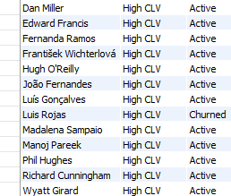
  - Medium CLV customers
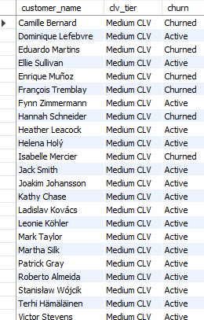
  - Low CLV customers
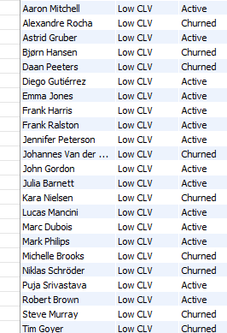
  - Summary
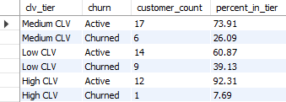

Insights
  - High CLV customers are far more likely to remain active, with over 92% still engaged.
  - Medium CLV customers show a moderate churn rate (about 26%), indicating some risk but also good retention potential.
  - Low CLV customers have the highest churn rate (nearly 39%), suggesting weaker loyalty and higher disengagement risk.
  - There is a clear inverse relationship between CLV tier and churn: higher-value customers are more loyal and less likely to churn.

Suggestions
  - Prioritize retaining High CLV customers through loyalty programs, exclusive offers, and continued engagement to protect their value.
  - Target Medium CLV customers with tailored campaigns to move them up into the High CLV tier and reduce churn risk.
  - Focus reactivation efforts on Low CLV churned customers selectively, as they pose the highest churn risk and lowest value potential.

- Visualisation
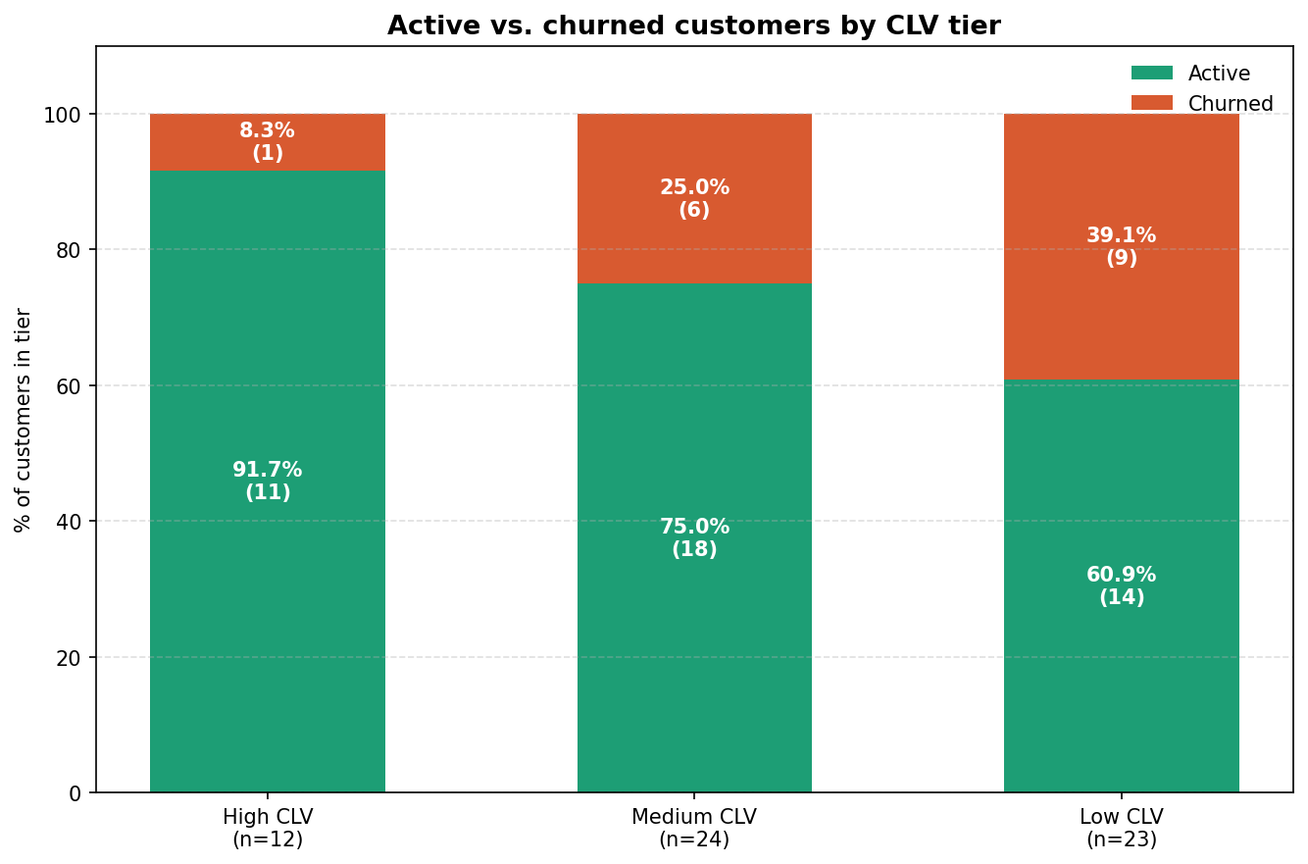

- If data on promotional campaigns (discounts, events, email marketing) is available, how could you measure their impact on customer acquisition, retention, and overall sales?
Answer

Reference
    - Tables needed (if available):
      - Campaign details (type, start and end dates, target segment, offer details)
      - Customer interactions (which customers received or engaged with the campaign)
      - Purchases during and after campaigns
    - Metrics to measure:
      - Acquisition: number of new customers acquired during campaign period
      - Retention: churn rate reduction or increase in repeat purchases after campaign
      - Sales: incremental revenue attributable to the campaign

Approach
    - Link campaign participation data to customer and purchase data.
    - Define exposed group (customers exposed to campaign) and
not_exposed group (customers not exposed).
    - Compare metrics before, during, and after the campaign for both groups:
      - Customer acquisition: count of customers making their first purchase during the campaign period.
      - Customer retention: compare churn rates and purchase frequency before and after campaign.
      - Sales lift: difference in total and average revenue between periods and between exposed & not_exposed groups.

Insights
    - Promotional campaigns can significantly drive new customer acquisition, especially if targeted effectively.
    - Campaigns often improve customer retention by re-engaging dormant customers and increasing repeat purchases.
    - Campaigns that result in higher incremental sales and improved retention deliver better ROI.
    - The magnitude of impact depends on the campaign type, target segment, and execution.

Suggestions
    - Track and record campaign participation at customer level to enable clear before/after analysis.
    - Always include a control group or pre-campaign baseline to isolate campaign impact.
    - Calculate ROI to assess whether the campaign’s incremental revenue outweighs its cost.
    - Use insights to refine future campaigns, targeting segments and tactics that show the highest response.

- How would you approach this problem, if the objective and subjective
questions weren't given?
Answer

Reference
    - Dataset: Chinook database
    - Tables: customer, invoice, invoice_line, track, genre, album, artist, employee, etc.
    - Business context: music store database — sales, customer behavior, artist and genre preferences, geographic patterns.
    - Goal: uncover trends, anomalies, opportunities in customer, sales, and product data.

Approach
  - Step 1: Understand the data
    - Explore the schema: identify all tables, columns, keys, and relationships.
    - Review the types of data available: customer profiles, sales transactions, product catalog, employees, and locations.
    - Understand the date ranges and completeness of the data.
- Step 2: Clean and validate
  - Check for missing, inconsistent, or duplicate data.
  - Validate foreign key relationships.
  - Summarize record counts and distributions to check for anomalies.
- Step 3: Define key business dimensions
  - Customers: who buys (segmentation)?
  - Products: what sells (tracks, albums, genres, artists)?
  - Geography: where does demand come from (countries, cities)?
  - Time: when does demand peak (seasons, months)?
  - Employees: who manages accounts?
- Step 4: Analyze systematically
  - Descriptive: summarize overall sales, customer count, average spend.
  - Behavioral: study customer purchase frequency, basket size, churn.
  - Product: identify top-selling tracks, albums, artists, genres.
  - Geographic: compare sales and behavior across regions.
  - Trends: identify trends over time.
  - Operational: evaluate employee workloads and performance (if relevant).
- Step 5: Discover patterns & insights
  - Look for correlations: e.g., customer tenure vs spend, genre vs location.
  - Identify high-value and at-risk customers.
  - Detect underperforming products or regions.
  - Analyze affinities: what products are bought together?
- Step 6: Formulate recommendations
  - Suggest ways to improve revenue, retention, and engagement.
  - Propose targeted campaigns, bundles, or loyalty programs.
  - Recommend operational improvements based on findings.
- Step 7: Presentation
  - Summarize findings using clear charts and visualizations to communicate insights effectively.
  - Present actionable recommendations alongside supporting visuals.
  - Tailor presentation to both technical (data-driven) and business (decision-making) audiences.

- How can you alter the "Albums" table to add a new column named "ReleaseYear" of type INTEGER to store the release year of each album?
Answer

Reference
    - Table album in the dataset
    - Current columns:
      - album_id (Primary key)
      - title (Name of the album)
      - artist_id (Foreign key)

Approach
    - Use the SQL ALTER TABLE statement to add a new column.
    - Specify the column name ‘ReleaseYear’ and data type INT.

Query
ALTER TABLE album
ADD COLUMN ReleaseYear INTEGER

SELECT * FROM album

Output
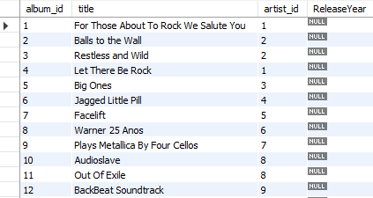
- Insights
  - Added a new column named ReleaseYear to the album table.
  - The column is of type INTEGER and allows NULL by default (since no NOT NULL or DEFAULT is specified).
  - Existing rows will have NULL for this column until you update them.
  - These existing records can be populated using the UPDATE query:
    - UPDATE album
    - SET ReleaseYear = 1999
    - WHERE album_id = 1;

- Chinook is interested in understanding the purchasing behavior of customers based on their geographical location. They want to know the average total amount spent by customers from each country, along with the number of customers and the average number of tracks purchased per customer. Write an SQL query to provide this information.
Answer

Reference
    - Metrics:
      - Number of customers in each country.
      - Average total spend per customer.
      - Average number of tracks purchased per customer.

Approach
    - Aggregate per customer: total spend, tracks purchased, and country.
    - Aggregate per country:
      - Count customers.
      - Average of customer spend.
      - Average of tracks purchased per customer.

Query
WITH customer_summary AS ( SELECT c.country,
c.customer_id,
SUM(i.total) AS total_spent, SUM(il.quantity) AS total_tracks
FROM customer c
JOIN invoice i ON c.customer_id = i.customer_id JOIN invoice_line il ON i.invoice_id = il.invoice_id GROUP BY c.country, c.customer_id
)
SELECT country,
COUNT(customer_id) AS num_customers, ROUND(AVG(total_spent), 2) AS avg_spent_per_customer, ROUND(AVG(total_tracks), 2) AS avg_tracks_per_customer
FROM customer_summary GROUP BY country ORDER BY country;

Output
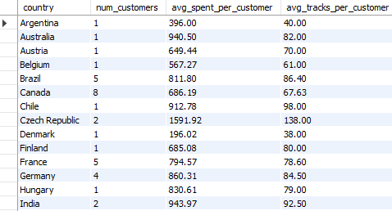
- Insights
  - Czech Republic and Ireland have the highest average spend per
customer, at $1,591.92 and $1,433.52 respectively, with high average track purchases too indicating very high-value customers in small segments.
  - USA has the largest customer base (13), with solid average spend ($800.45) and track purchase rates (~81), making it a stable,
high-volume market.
  - Other strong markets include Spain, Chile, and India, which show both high spend and high tracks per customer.
  - Denmark has the lowest spend and smallest basket size, indicating low engagement in that region.

Suggestions
  - Focus premium offers and personalized campaigns on Czech Republic, Ireland, Spain, Chile, and India - high-value, loyal segments despite small numbers.
  - USA remains a critical market due to its volume and steady average spend continue broad-based promotions there.
  - Investigate low-engagement markets like Denmark and Italy to understand barriers and improve participation.

Thank You

